 My RSI/CTS tips/links

Note: all of this is my personal experience, people vary a lot on these dimensions. I think the combo that worked best for me is:

1. Heating cream
2. Ellastic wraps OR vacation when it's bad or gloves when it's okay.
3. Ergo keyboard& mouse(vertical)
4. Frequent breaks and stretching.
5. Convenient monitor/desk placement like so. Also footrest helps <https://www.amazon.com/Fellowes-48121-70-Standard-Foot-Rest/dp/B00006I62X> . Most ppl need to raise their monitor w/ some books or so.
6. Good chair, footrest, desi with good height, etc.

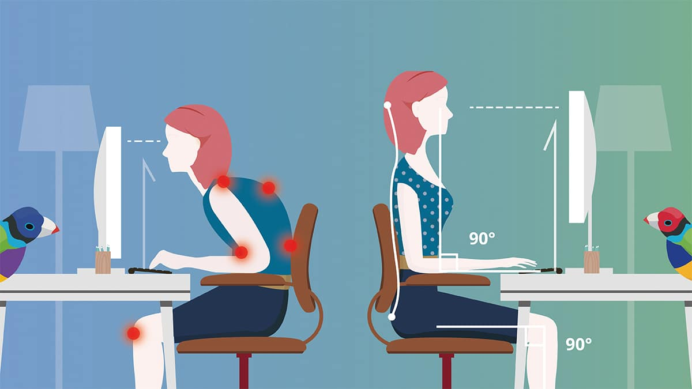

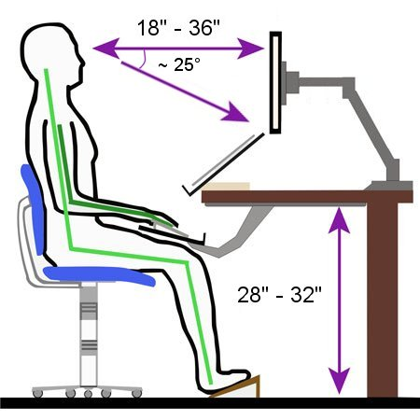

**Articles/ books/blog posts, etc**

Various advice by different people

<https://news.ycombinator.com/item?id=26104415>

<https://henrikwarne.com/2012/02/18/how-i-beat-rsi/>

Nice article I considered. Didn't take all the advice, but the one about a break program is nice. Also works if you do

Pomodoro (25 mins focused work on particular topic, 5mins rest.) instead.

<https://aaroniba.net/how-i-cured-my-rsi-pain>

I haven't read the stuff by Sarno (mind-body connection, but applied many of the other advice-

Massage, micro breaks, ergonomic stuff, sauna etc generally helps, but it's not like 'immediate pain relief'.

<http://xahlee.info/kbd/ergonomic_keyboards.html>

This guy is quite awesome re: ergonomic devices, check this article and maybe about trackballs/mice. The one I

Gave you is pretty similar to x-bows, so it's not a bad choice.

<http://xahlee.info/kbd/ergo_keyboard_for_small_hands.html>

Exercises to do regularly:

[Wrist Exercises for Tendinitis Carpal Tunnel Syndrome - Avoid RSI injury in just 2 minutes a day!](https://www.youtube.com/watch?v=fdD7CgN5FGg&ab_channel=Road)



Braces, gloves, wraps and heating creams:

I used heating creams+ ellastic wraps and this worked quite well in combination w/ keyboard and mice.

With the baby is a bit tricky as I always have to wrap/unwrap myself :(.

<https://www.verywellhealth.com/best-carpal-tunnel-braces-4169357>

If you wanna try the braces (my borhter had one of the big ones for the broken hand, I tried but for me it was quite inconvenient trying to work with it).

Maybe this would be good, maybe I will try it. Haven't tried myself, but the

<https://www.amazon.com/dp/B00PFUPRQ2?tag=dotdashvhealt-20&linkCode=ogi&th=1&psc=1&ascsubtag=4169357%7Cndb25d94a6c0c4d19a66d5d2865e4d8b711%7CB00PFUPRQ2>

Also this style of wrist wrap:

<https://www.amazon.com/dp/B00ZMZPGMK?tag=dotdashvhealt-20&linkCode=ogi&th=1&psc=1&ascsubtag=4169357%7Cndb25d94a6c0c4d19a66d5d2865e4d8b711%7CB00ZMZPGMK>

is not bad, for typing it's nice, at some point the velcro sticking material loses strength and it's annoying.

For doing finer things w/ mice it might be unfomfortable though. Bonus points for the velcro-type is you can use them for gym and it's not ugly.

Simple compression gloves like this:

<https://www.amazon.com/Arthritis-Compression-Rheumatoid-Osteoarthritis-Tendonitis/dp/B077X6Z332/ref=sr_1_12?keywords=arthritis+gloves&qid=1641211061&sprefix=arthri%2Caps%2C171&sr=8-12>

Also work quite well with heating cream, but it's for the 'good' periods, when you're feeling more pain you need something tighter.

Make sure the heating cream is comfortable (i.e. 'penetrates' the skin, I've had some that just burn me, but don't provide relief), don't touch sensitive tissues before washing etc…

Some scary stories:

<https://www.reddit.com/r/RSI/comments/22ge19/programmer_looking_for_advice_on_wrist_rsi/>